Introduction:
To understand math and geometry visualization is very important. For humans plotting two dimensional graph is very easy but even though what ever our eyes watch is three dimensional it is very difficult to visualize a three dimensional plot from the equation and plotting it. Now in the era of computer there are hundreds of software capable of plotting any kind of graph and MATLAB is one of the most sophisticated software for plotting and editing graph and mathematical equations and many more.

Objective:
The objective of this project is to make a graphing calculator using graphical user interface of MATLAB, that will graph and simulate two dimensional plot. It should also perform some tasks defined by the user like finding the minimum and maximum, showing the x and y ordinate of an user defined position in the graph and others. The design of this graphing calculator is open ended, so the designing of this calculator is fully up to the student and if they want they can add more functions to the calculator.

MATLAB Functions:
For this project i used more than ten predefined MATLAB functions. I will explain all the functions that I used in an alpha numerical order. In my for plotting I used x as horizontal, y as vertical and and z as the third dimension of the graph.
- clc, cla – these functions clear screen and and graph.
- contour3(x,y,z) – the countour3 function of MATLAB works same as mesh function, the difference is rather creating a surface plot it creates a contour plot from the information .
- diff(vector) – the diff function of MATLAB finds the numerical differentiation of the given vectors.
- ezplot('f(x,y)') – the ezplot function of MATLAB take an implicit argument of x and y, and plot them and accordingly in vertical and horizontal position.
- get(handle, 'property') – this function get the defined property from the object.
- gtext – this function enables the user to use the cursor to insert a string in the graph
- Isosurface(x,y,z,v,0) – isosurface function of MATLAB take four arguments x, y, z and v where v = f(x, y, z) and v = 0 then create a surface plot from the implicit equation of f(x,y,z) = 0
- Mesh(x,y,z) – the mesh function of MATLAB take a n x n matrix of x, y and z then create a surface plot out of it.
- num2str(double value) – this function convert the double to a string.
- plot(x, y) – the plot fucntion of MATLAB take two variable (x and y coordinate points) and plot them.
- Polar(tht, r) – the polar function of MATLAB create polar plot of r and theta.
- set(handle, 'Property', 'property value') – set command works with objects to set properties of the object.
- str2num('String') – this function convert the string to a double value.
- Strcat('String1', 'String2') – this function concatenate two string.
- text(x, y, z, 'String') – this function insert the user defined string in a predefined location

Procedure:
The guide command of MATLAB in command window open the graphical user interface for the MATLAB. From there under the creates new GUI tab, Blank GUI has to be selected. It will open the graphical user interface to design software and program with user interface. After saving the file it will save it as a .fig file. Now the .fig file is editable file in MATLAB. In editing mode of .fig file, in the left side there is a tool bar to select push-button, graphing window, text-box, edit-box and others to design. The first thing is to create a good graphical user interface to experience a better looks. After that GUI for the calculator of the project has been designed and simulated. The GUI of my project looks like

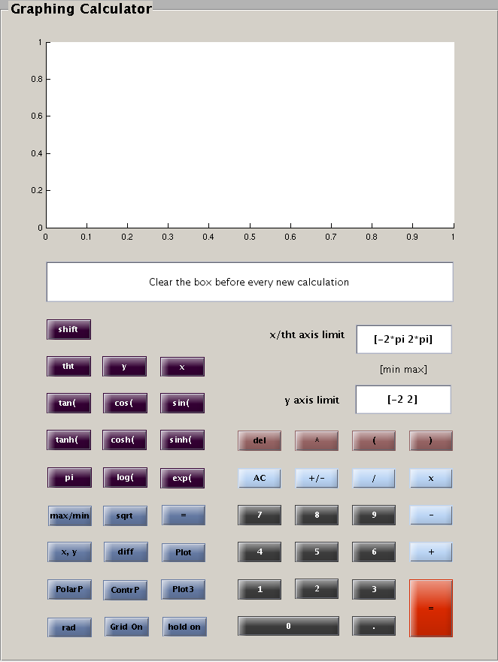
Fig: GUI of the Calculator

After running the GUI it will generate a .m file related to the figure. It will also generate function for all the object that has been used to create the GUI. While crating the GUI the tag for all the objects has been changed according to the name of the object. It will help later to find the appropriate function to manipulate the object.
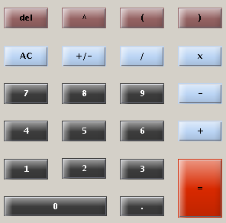
Fig: A fragment of the calculator

for this part of the GUI all the buttons uses same programming accept for the '=', 'AC', 'del' and the '+/-' buttons. And the code for the buttons is

function Tag_Callback(hObject, eventdata, handles)
% hObject handle to dec (see GCBO)
% eventdata reserved - to be defined in a future version of MATLAB
% handles structure with handles and user data (see GUIDATA)
% get the current string from the display
textString = get(handles.Tag2, 'String');
textString = strcat(textString, get(handles.Tag, 'String'));
set(handles.Tag2, 'String', textString);

here Tag is the name of the functions for the buttons and Tag2 is the name of the function of the edit box. The first line get the function as a string form the edit box. The second line get the font from the buttons and concatenate with the previous string. The third line set the new string in the edit box.

Code for the 'del' button

function del_Callback(hObject, eventdata, handles)
textString = get(handles.edit2, 'String');
len = length(textString);
textString(len) = [];
set(handles.edit2, 'String', textString);

Code for the 'del' button

this function delete the last character from the edit box. The fist line of the code do the same this as expected. The third line delete the last character and forth line set the character in the edit box.

function clear_Callback(hObject, eventdata, handles)
set(handles.edit2, 'String', '');
title('')
cla;

this function of the button AC clear everything.
Code for the '+/-' button

function plus_min_Callback(hObject, eventdata, handles)
textString = get(handles.edit2, 'String');
if textString(1) ~= '-'
textString = strcat('-', textString);
else
textString(1) = [];
end
set(handles.edit2, 'String', textString);

this function of '+/-' button allow the user to add + or – sign in front of the string of the edit box. The if else statement decide whether to add a plus or minus sign to the string. The last line set the string to edit box.

Code for the '+/-' button

function evalute_Callback(hObject, eventdata, handles)

textString = get(handles.edit2, 'String');
if length(textString) ~= 0
textString = eval(textString);
end
set(handles.edit2, 'String', textString);

this function of '=' button take the string form the edit box and evaluate it numerically and set the answer to the edit box.
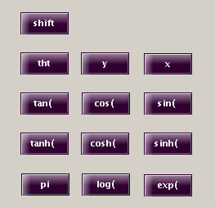
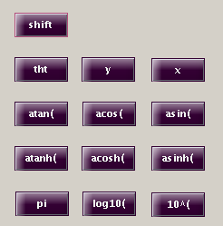
Figure: Buttons form the calculator

This buttons of the calculator used for the default functions. The user can use these default function or can manually input the function in the edit box. This buttons of this GUI uses the same programming code as explained earlier. And the code is

function Tag_Callback(hObject, eventdata, handles)
textString = get(handles.Tag2, 'String');
textString = strcat(textString, get(handles.Tag, 'String'));
set(handles.Tag2, 'String', textString);

the code for the shift button is different it uses to toggle the button from one state to another as shown in previous figures. When shift has been pressed it change all sin functions to it inverse functions. The code for this button is

function pushbutton39_Callback(hObject, eventdata, handles)
global toggle;
if toggle ~ 0
toggle = 1-toggle;
set(handles.sin, 'string', 'sin(');
set(handles.cos, 'string', 'cos(');
set(handles.tan, 'string', 'tan(');
set(handles.sinh, 'string', 'sinh(');
set(handles.cosh, 'string', 'cosh(');
set(handles.tanh, 'string', 'tanh(');
set(handles.log, 'string', 'log(');
set(handles.exp, 'string', 'exp(');
else
toggle = 1;
set(handles.sin, 'string', 'asin(');
set(handles.cos, 'string', 'acos(');
set(handles.tan, 'string', 'atan(');
set(handles.sinh, 'string', 'asinh(');
set(handles.cosh, 'string', 'acosh(');
set(handles.tanh, 'string', 'atanh(');
set(handles.log, 'string', 'log10(');
set(handles.exp, 'string', '10^(');
end

this part of the code use to toggle the button. If shift has been pressed which means it has been toggled it will set all the button with different functions. If shift button has been pressed again it will restore the previous functions.

suzan seligman intro to music......

